Sudeepto Roy

1546008

JS MASTER

We got a hint as HEX Time.

On opening the given link, we got 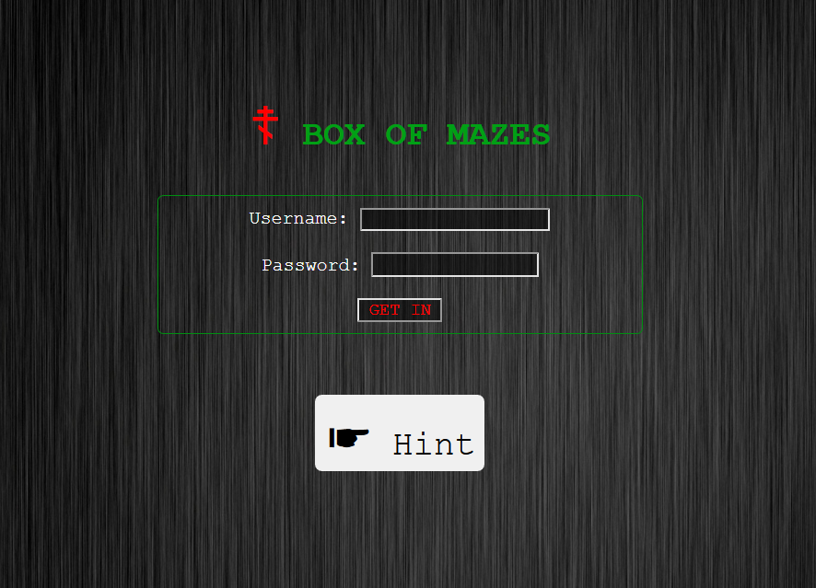

On analysing the source code, we found this

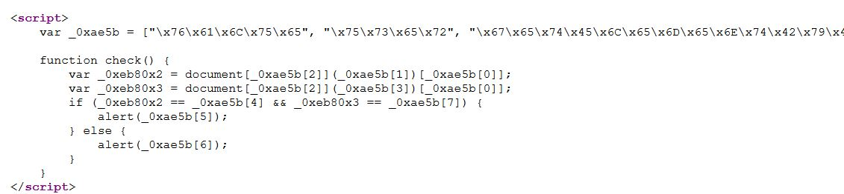

So we converted the hex in the arrays to ascii using online hex to ascii converter.

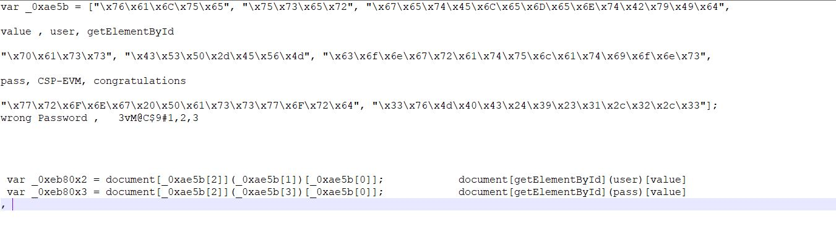

From this we got the user and password, which we entered in the login page and we got the flag !!!!!!.

